**OLABISI ONABANJO UNIVERSITY**

**MECHANICAL ENGINEERING DEPARTMENT**

**Mechanical Engineering Programme**

**MATERIAL SCIENCE AND ENGINEERING**

**LABORATORY**

**200 LEVEL**

**NAMES…………………………………………………………………………………..**

**MATRIC. NO. :……………………………… LEVEL: ………………………………**

**DEPT.: ………………………………………. GROUP NO: …………………………**

**COURSE:……………………………………. CODE: ………………………………..**

**DATE:…………………SESSION:………………SIGNATURE…………………….**



**OLABISI ONABANJO UNIVERSITY**

**COLLEGE OF ENGINEERIG & ENVIRONMENTAL STUDIES**

**AGRICULTURAL/MECHANICAL ENGINEERING DEPARTMENT**

**IBOGUN CAMPUS.**

**EXPERIMENT 1**

**TITLE**: PHYSICAL AND MECHANICAL PROPERTIES OF MATERIALS

**AIM**: To determine (i) the physical properties of the materials (ii) elastic limit

(iii) yield point (iv) percentage elongation (v) reduction of area

**APPARATUS:** Tensile Testing Machine, Vernier Caliper, Micrometer screw gauge, Pressure gauge, Test pieces (mild steel, brass, copper & aluminium)

**INTRODUCTION:**

The mechanical property of material is the ability of the material to resist mechanical forces and loads which are ascertained by performing carefully designed laboratory experiments that replicate as nearly as possible the service conditions. Mechanical properties include strength, elasticity, plasticity, ductility, stiffness, malleability, brittleness, hardness, resilience, toughness, creep and fatigue.

Mechanical testing of engineering materials is carried out for a number of reasons: to simulate the service conditions of a material, to predict its *service performance,* to provide engineering *design data* and to check whether the material meets the specification.

The mechanical behaviour of a material reflects the relationship between its response and deformation to an applied load or force. It is one of the important criteria in design, fabrication and material selection for engineering application. Important mechanical properties are strength, hardness, ductility, and stiffness.

Property defines the quality of the specific characteristic of a metal.

The physical properties of materials includes density, hardness, elastic modulus, melting point, damping capacity, heat capacity, thermal conduction, thermal expansion, electrical conduction and colour.

Testing and inspection are very important in engineering activities which must be done at various stages in engineering process, design, assembly and components/machines production to meet a specific requirement.

Two major group of test are Destructive and Non-destructive to establish the properties of materials and to determine the integrity of the materials.

**Destructive Test**- The test specimen is tested until it‘s structural failed completely in order to determine its mechanical properties and characteristic. The test can be performed by tensile test, compression test, impact test, Hardness test, creep test, fatigue test.

Destructive: Tensile test is used for mechanical test of metals. It gives accurate information of the properties of the materials. A rectangular/flat or circular test-piece is tighten/secured at both ends and pulled till the test-piece breaks. It would prove the material elasticity, the elastic limit and its breaking point.

**Non-destructive**: The test material maintained the same mechanical properties before and after the test, the test piece is still serviceable after subjected to loading conditions. Hardness test is used to determine the resistance to deformation. The hardness of the material can be measured from the depth, size and shape of the indentation

The three methods used in hardness test include:

Brinell test- a hardened ball/diamond point is pressed into the surface of the materials for a given period at a given load/force.

Rockwell test- The test is completed using a small ball or cone. The resultant test does not damage the material.

**THEORY**

**The Tensile test**

The tensile test is widely used for measuring the stiffness, strength and ductility of a material. The testing machine subjects the test-piece to an axial *elongation* and the resultant *load* on the specimen is measured. Depending on the nature of the product being tested, the specimen may be round or rectangular in cross-section, with the region between the grips usually being of reduced cross–section. The *gauge length* is marked in the region.

Stress = Load/Cross-sectional area

Strain = Extension of gauge length/Original gauge length,

Test-pieces: To complete a tensile test, a test piece in the figure below is used Lo – Original length, Do – Original Diameter

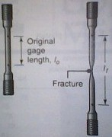 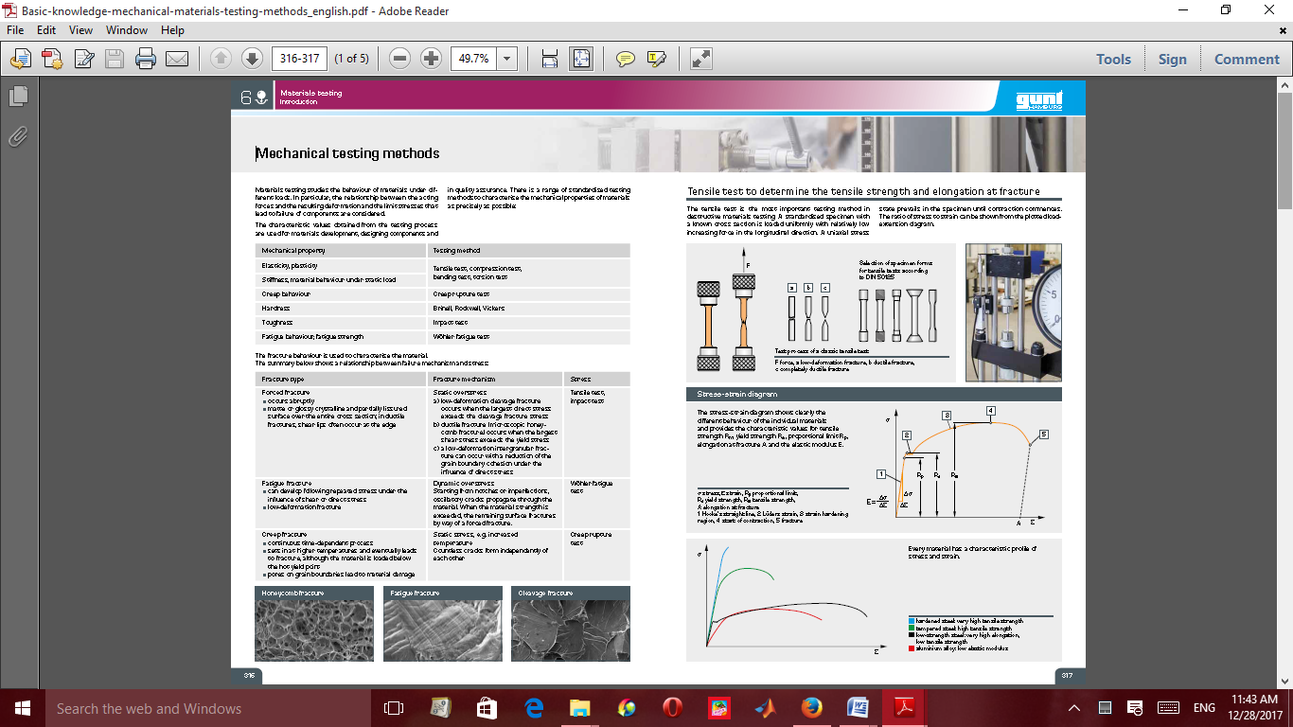

Figure 1a: Test piece with a circular cross-section

IMG0237A

Figure 1b: Specimen after elongation

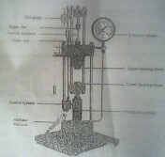

Figure 2a: Tensile Testing Machine

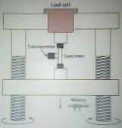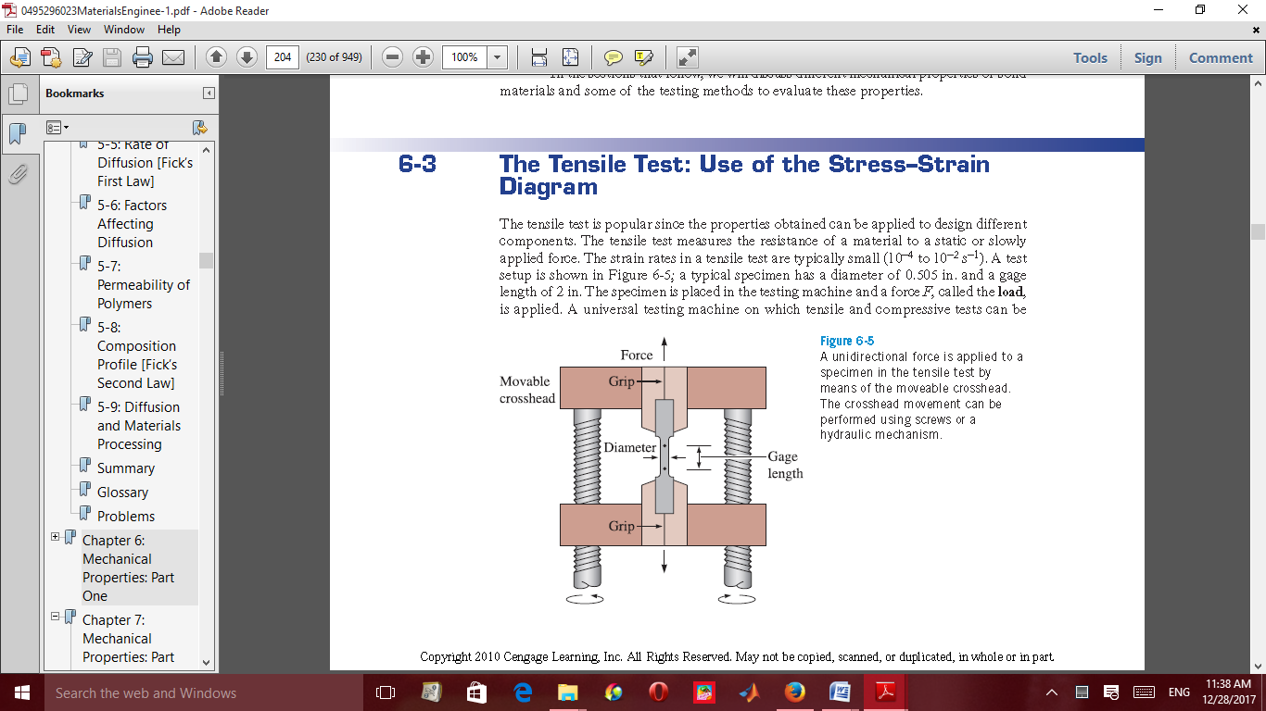

Figure 2b - Schematic representation of the Tensile testing machine

**PROCEDURE**

The threaded ends of the circular cross-sectional test piece are screwed into the jaws on the tensile test machine. The rod is smoothly tapered out to the threaded part, on the parallel centre part are two marks, which are at a distance apart of five times the diameter: Lo – 5Do where Lo is Original length, Do is Original Diameter. After the test, the marks are to judge the plasticity of the material.

TEST READINGS – A test piece is screwed into the jaws and the jaw is slowly pulled apart. The force is increased and test piece stretched before it’s finally breaks. The quantities to be measured during the test are the tensile strength F and extension ΔL of the test quantities to calculate the tensile strength δ(N/mm2), F/A, the ratio of force per unit area and strain ϵ which is a ratio of change in length /original length.

Hook’s Law is the relationship between the stress and the strain. E =δ/ϵ (E is modulus of elasticity)

Table 1.1: Value of materials Properties

|  |  |
| --- | --- |
| Materials | Modulus of elasticity E (N/mm2) |
| Iron | 200 |
| Copper | 125 |
| Brass | 100 |
| Aluminium | 72 |

**TEST ON THE MATERIALS** (Cast iron/mild Steel, Brass and Aluminium).

i. Measure the diameter of the test pieces on the grooved surface.

ii. Measure the distance of the test pieces (5mm away on both sides from the centre and            mark the point with pencil).

     iii. Mount the dial gauge on the small rod beside the machine jaws.

iv. Screw in the test piece into the jaws.

v.  Tension the test piece by winding up the knob on the top of the hydraulic cylinder.

vi. Set both pressure gauge and dial gauge to Zero.

vii. Slowly and carefully load the machine by turning the pressure handle clockwise.

viii. Read off the pressure gauge at interval of 1KN and the corresponding dial gauge            accordingly.

ix. Continue loading until then test piece breaks and note the breaking point.

x. Remove the two halves of the test piece, put them together on the bench and re-measure         both the final diameter and final length.

   xi. Repeat the same procedure for the other materials specimen provided.

**Table of Results for the materials, (Mild Steel, Cast Iron, Brass, Copper or Aluminium)**

Original Length = …………. mm

Final Length = ………….. mm

Original Diameter = ………… mm

Final Diameter = …………… mm

Table 1.2: Table of Results

|  |  |  |  |  |  |
| --- | --- | --- | --- | --- | --- |
| FORCES    (KN) | FINAL LENGTH (mm) | ORIGINAL LENGTH (mm) | ELONGATION       (mm) | STRESS | STRAIN |
| 1 |  |  |  |  |  |
| 2 |  |  |  |  |  |
| 3 |  |  |  |  |  |
| 4 |  |  |  |  |  |
| 5 |  |  |  |  |  |
| 6 |  |  |  |  |  |

Note: The table of results is for each material

EXERCISES

(a) Plot the graph of (i) Force against the Elongation, (ii) Elongation against Original length and (iii) Stress against strain

(b) Determine from the graph: (i) Maximum force of the material (ii) The tensile strength (Ultimate tensile stress), (iii) The fracture stress, (iv) Percentage Elongation, (v) Percentage Reduction in area

(c) Compare the curves on the graph and briefly explain your observations on the difference in the tested material properties.

(d) A piece of copper originally 305 mm long is pulled in tension with a stress of 276 MPa. If the deformation is entirely elastic, what will be the resultant elongation?

(e) A tensile stress is to be applied along the long axis of a cylindrical brass rod that has a diameter of 10 mm. Determine the magnitude of the load required to produce a 2.5 x 103mm change in diameter if the deformation is entirely elastic.

(f) Define the following terms Resilience, toughness, Ductility, yield stress.

(g) State the major function of Extensometer.

(h) State the necessary precautions observed during the experiment.

**Experiment 2**

**Title: Rockwell Hardness test**

**Objective:** To determine the hardness the Hardness of the given Specimen using Rockwell hardness test.

**Equipment and Materials:** Rockwell hardness testing machine, Black diamond cone indenter, Hard steel specimen.

**Theory**

The test is an indentation test used for smaller specimens and harder materials.

The test forced indenter into the surface of a test piece in two operations, measuring the permanent increase in depth of an indentation from the depth increased to the depth reached under a datum load due to an additional load.

Measurement of indentation is made after removing the additional load. Indenter used is the cone having an angle of 120 degrees made of black diamond.

NOTE: Thickness of the specimen should not be less than 8 times the depth of indentation to avoid the deformation to be extended to the opposite surface of a specimen.

Indentation should not be made nearer to the edge of a specimen to avoid unnecessary concentration of stresses. In such case distance from the edge to the centre of indentation should be greater than 2.5 times diameter of indentation.

Rapid rate of applying load should be avoided. Load applied on the ball may rise a little because of its sudden action. Also rapidly applied load will restrict plastic flow of a material, which produces effect on size of indentation.

**Diagram**

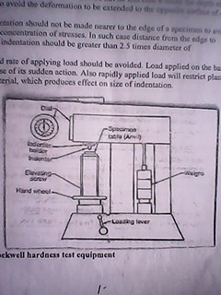

**Figure 2.1: Rockwell hardness test equipment**

**Procedure**

1. Examine hardness testing machine Figure 2.1.
2. Place the specimen on platform of a machine. Using the elevating screw raise the platform and bring the specimen just in contact with the ball. Apply an initial load until the small pointer shows red mark.
3. Release the operating valve to apply additional load. Immediately after the additional load applied, bring back operating valve to its position.

iv Read the position of the pointer on the scale, which gives the hardness number.

1. Repeat the procedure five times on the specimen selecting different points for indentation.

**RESULTS AND CALCULATION**

1. Take five values of indentation of each specimen and obtain the average.
2. Observe and record the hardness number from the dial of a machine.
3. Compare Brinell and Rockwell hardness tests obtained.
4. Determine the hardness of the given specimen

**Experiment 3**

**Title: Brinell hardness test.**

**Aim:** To determine the hardness of the given specimen using Brinell hardness test.

**Equipment and Materials:** Brinelll hardness testing machine, Ball indenter, Aluminum specimen.

**Theory:**

Hardness of a material is defined as Resistance to the permanent indentation under static and dynamic load. When a material is required to use under direct static or dynamic loads, only indentation hardness test will be useful to find out resistance to indentation.

In Brinell hardness test, a steel ball of diameter (D) is forced under a load (F) on to a surface of test specimen. Mean diameter (d) of indentation is measured after the removal of the load (F).

NOTE: Thickness of the specimen should not be less than 8 times the depth of indentation to avoid the deformation to be extended to the opposite surface of a specimen. Indentation should not be made nearer to the edge of a specimen to avoid unnecessary concentration of stresses. In such case distance from the edge to the centre of indentation should be greater than 2.5 times diameter of indentation.

Rapid rate of applying load should be avoided. Load applied on the ball may rise a little because of its sudden action. Also rapidly applied load will restrict plastic flow of a material, which produces effect on size of indentation. Surface of the specimen is well polished, free from oxide scale and any foreign material.

**DIAGRAM**

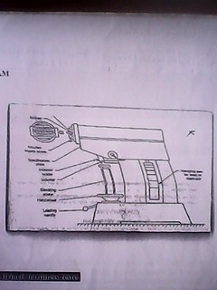

**Figure 3.1: Brinell Hardness Equipment**

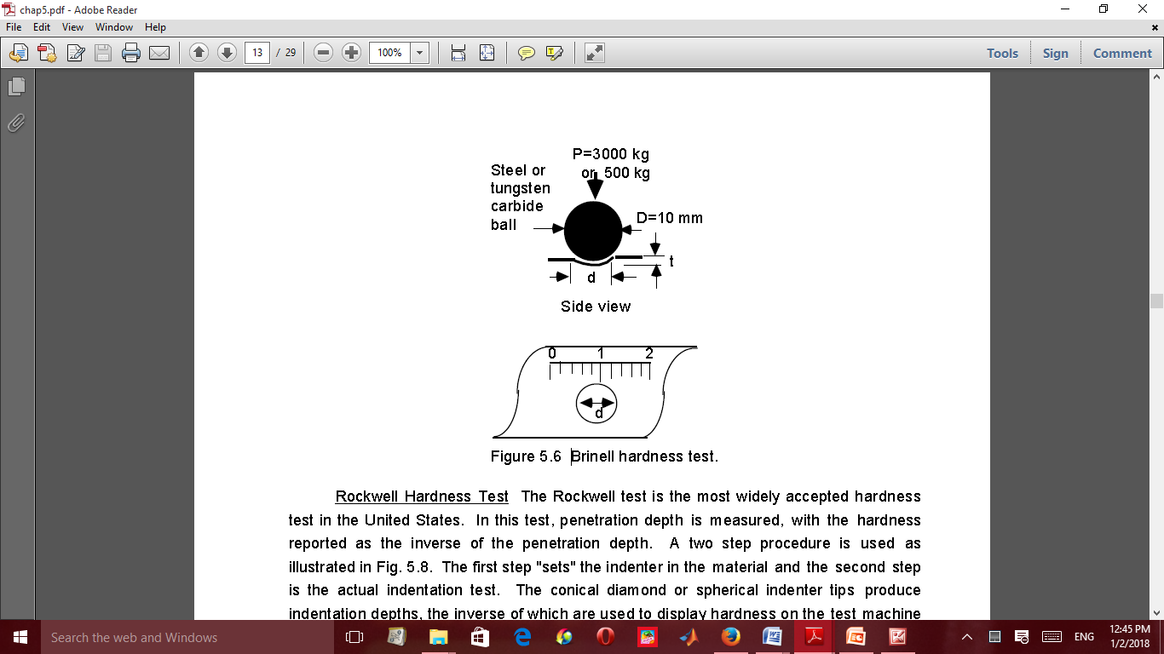

**Figure 3.2: Brinell hardness test**

**Procedure**

1. Select the load to be applied for hardness test according to the expected hardness of the material.
2. Keep the test load equal to 30 times the square of the diameter of the ball (diameter in mm) F=30D2 (Where ball diameter, generally taken as 10 mm).
3. Apply the load for a minimum of 15 seconds to 30 seconds. [ time for ferrous metals to be tested will be 15 seconds and softer metal will be 30 seconds]
4. Remove the load and measure the diameter of indentation nearest to

0.02 mm using microscope (projected image), magnifying lens (glass)

Guidelines on hardness range for standard loads are shown below in Table 3.1.

**Table 3.1: Specification of materials and load**

|  |  |  |
| --- | --- | --- |
| **Ball diameter** | **Load (kg)** | **Range of Brinell hardness** |
| **10** | **3000** | 96 to 600 |
| **10** | **1500** | **48 to 300** |
| **10** | **500** | **16 to 100** |

where D is the diameter of ball indenter and d is the diameter of indentation.

Hardness numbers normally obtained under 3000 kg and 10 mm diameter ball used for different materials are stated below

Table 3.2: Material Hardness Specification

|  |  |
| --- | --- |
| MATERIALS | HARDNESS NUMBERS |
| Medium carbon steel | 100 to 500 |
| Structural Steel | 130 to 160 |
| Hard Steel | 800 to 900 |

Note: Brinell test is not recommended for the materials having HB over 630.

It is important to observe and know the ball size and load with the hardness test when standard size of ball and load are not used. Because indentation done by different size of ball and load on different materials are not geometrically similar due to the different in size. When load is applied, ball also undergoes deformation and the material response to the load is not always the same

**RESULTS AND CALCULATION**

i. Take average of five values of indentation of each specimen. Obtain the hardness number from    equation.

ii. Compare Brinell and Rockwell hardness tests obtained.

iii.Calculate Brinell hardness number (HB) of the specimen

**Experiment 4**

**Title: Izod Test**

**Equipment and Material:** Impact testing machine, 2. Specimen and v notch (Size of the specimen is 10mm X 10mm X 75mm)

**Diagram**

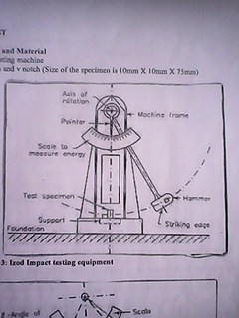

**Figure 4.1: Izod Impact testing equipment**

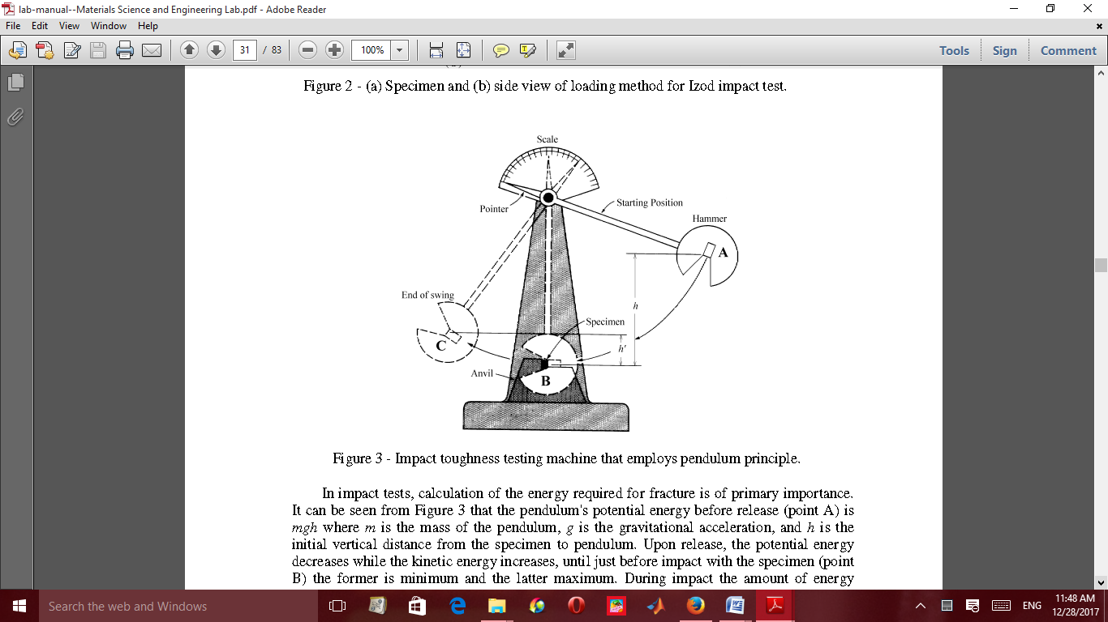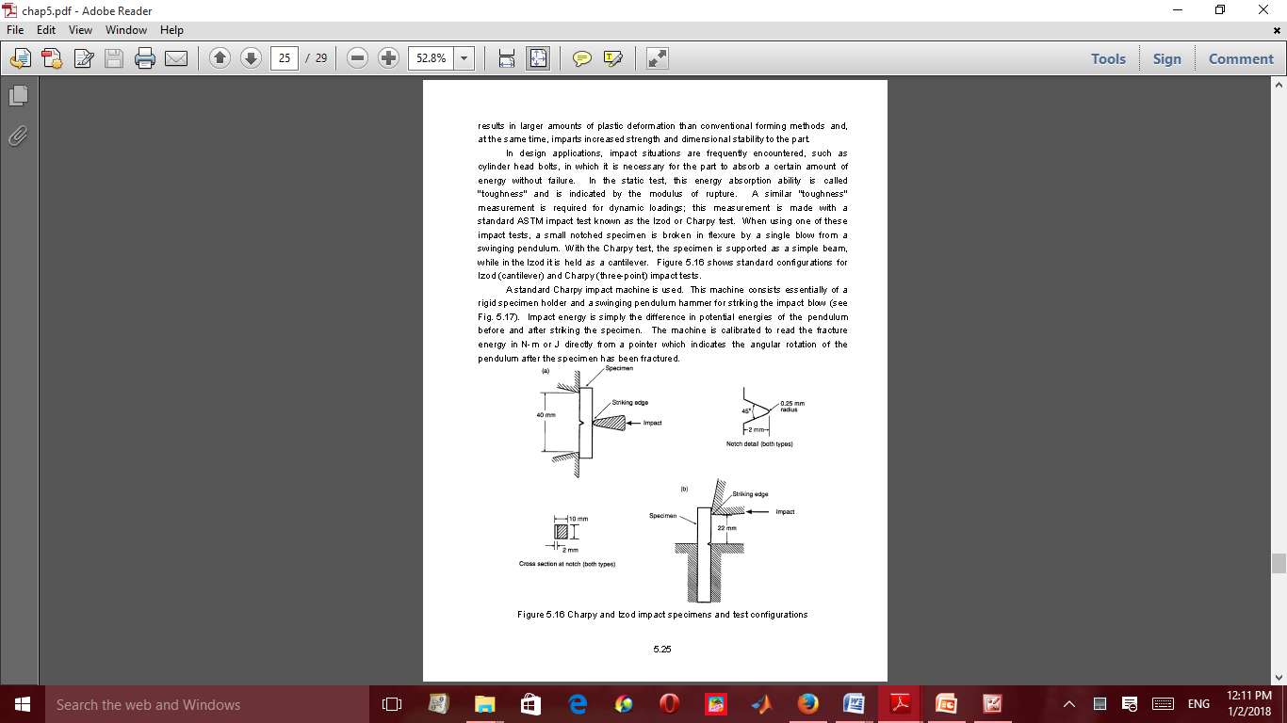

**Figure 4.2: Schematic impact testing that employs pendulum principle**

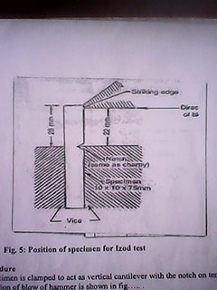 

**Figure 4.3: Position of specimen for Izod test**

**Procedure:**

1. Specimen is clamped to act as vertical cantilever with the notch on tension side.

Direction of blow of hammer is shown in figure 4.2

2. Measure the dimensions of a specimen and that of the notch.

3. Raise the hammer of the machine and note down initial reading from the dial pointer, which indicate the energy to be used to fracture the specimen.

4. Place the test specimen at the centre with respect to hammer and check the position of notch.

5. Release the hammer and note the final reading to determine the actual energy required to fracture the Specimen.

6. Repeat the test for other materials specimens.

7. Compute the energy of rupture of each specimen.

**Results and Calculation**

Record the Initial and final reading of the dial in tabular form.

Determine the Strain energy of the given specimen.

**Experiment 5**

**TITLE: CHARPY TEST**

**Equipment and Material:** Impact testing machine, U notch cut across the middle of one face

**Diagram**

.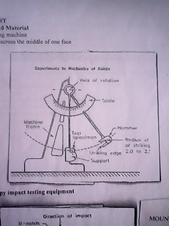

**Figure 5.1: Charpy impact testing equipment**

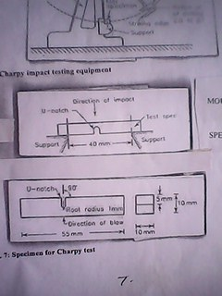

**Figure 5.2 Method of mounting the specimen**



**Figure 5.3: Specimen for Charpy test**

**Procedure:**

**Mounting of specimen**

1. Specimen is mounted on a beam supported at each end and the hammer is allowed to hit the specimen at the opposite face behind the notch.

2. Measure the dimensions of a specimen and of the notch.

3. Raise the hammer and note down initial reading from the dial indicator, which will be energy to be used to fracture the specimen.

4. Placed the specimen for test at the centre with respect the hammer and check the position of notch.

5. Release the hammer and note the final reading to give the actual energy required to fracture the Specimen.

6. Repeat the test for other materials.

**Results and Calculation**

1. Record the initial and final readings of the dial in tabular form.

2. Compute the energy of rupture of each specimen.

3. Determine the strain energy of given specimen.

***PRACTICAL REPORT***

NOTES:

………………………………………………………………………………………………….......................................................…..................................................................................................................................................................……………………………………………………………………………………………………........................................................................................................................................................................................................................……………………………...***………………………………………………………………………………………………………………………………………………………………………………………………………………………………………………………………………………………………………………***

………………………………………………………………………………………………….......................................................…..................................................................................................................................................................……………………………………………………………………………………………………........................................................................................................................................................................................................................……………………………

………………………………………………………………………………………………….......................................................…..................................................................................................................................................................……………………………………………………………………………………………………........................................................................................................................................................................................................................……………………………

………………………………………………………………………………………………….......................................................…..................................................................................................................................................................……………………………………………………………………………………………………........................................................................................................................................................................................................................……………………………

………………………………………………………………………………………………….......................................................…..................................................................................................................................................................……………………………………………………………………………………………………........................................................................................................................................................................................................................……………………………

………………………………………………………………………………………………….......................................................…..................................................................................................................................................................……………………………………………………………………………………………………........................................................................................................................................................................................................................……………………………

………………………………………………………………………………………………….......................................................…..................................................................................................................................................................……………………………………………………………………………………………………........................................................................................................................................................................................................................……………………………

***………….…………………………………………………………………………………………………………………………………………………………………………………………………………………………………………………………………………………………………………………………………………………………………………………………………………………………………………………………………………………………………………................................................................................................................................................................……………***

………………………………………………………………………………………………….......................................................…..................................................................................................................................................................…………….………………………………………………………………………………………........................................................................................................................................................................................................................……………………………

........................................................................................................................................................................................................................................................................................................................................................................................................................................................................................................................

........................................................................................................................................................................

................................................................................................................................................................................................................................................................................................................................................

........................................................................................................................................................................................................................................................................................................................................................................................................................................................................................................................

.................................................................................................................................................................................................................................................................................................................................................................................................................................................................................................

………………………………………………………………………………………………….......................................................…..................................................................................................................................................................……………………………………………………………………………………………………........................................................................................................................................................................................................................……………………………

………………………………………………………………………………………………….......................................................…..................................................................................................................................................................……………………………………………………………………………………………………..............................................................................

……………………………………………………………………………………………………………………………………………………………………………………………………………………………………………………………………………………………………………………………………………………………………………………………………………………………………….......................................................…..................................................................................................................................................................……………………………………………………………………………………………………........................................................................................................................................................................................................................……………………………

………………………………………………………………………………………………….......................................................…..................................................................................................................................................................……………………………………………………………………………………………………........................................................................................................................................................................................................................……………………………

………………………………………………………………………………………………….......................................................…..................................................................................................................................................................……………………………………………………………………………………………………........................................................................................................................................................................................................................……………………………

………………………………………………………………………………………………….......................................................…..................................................................................................................................................................……………

………………………………………………………………………………………........................................................................................................................................................................................................................……………………………

………………………………………………………………………………………………….......................................................…..................................................................................................................................................................……………………………………………………………………………………………………........................................................................................................................................................................................................................……………………………

………………………………………………………………………………………………….......................................................…..................................................................................................................................................................……………………………………………………………………………………………………..............................................................................

………………………………………………………………………………………………….......................................................…..................................................................................................................................................................……………………………………………………………………………………………………........................................................................................................................................................................................................................……………………………

………………………………………………………………………………………………….......................................................…..................................................................................................................................................................……………………………………………………………………………………………………........................................................................................................................................................................................................................……………………………

........................................................................................................................................................................................................................................................................................................................................................................................................................................................................................................................

........................................................................................................................................................................

................................................................................................................................................................................................................................................................................................................................................

........................................................................................................................................................................................................................................................................................................................................................................................................................................................................................................................

.................................................................................................................................................................................................................................................................................................................................................................................................................................................................................................

………………………………………………………………………………………………….......................................................…..................................................................................................................................................................……………………………………………………………………………………………………........................................................................................................................................................................................................................……………………………

………………………………………………………………………………………………….......................................................…..................................................................................................................................................................……………………………………………………………………………………………………..............................................................................

……………………………………………………………………………………………………………………………………………………………………………………………………………………………………………………………………………………………………………………………………………………………………………………………………………………………………….......................................................…..................................................................................................................................................................……………………………………………………………………………………………………........................................................................................................................................................................................................................……………………………

………………………………………………………………………………………………….......................................................…..................................................................................................................................................................……………………………………………………………………………………………………........................................................................................................................................................................................................................……………………………

………………………………………………………………………………………………….......................................................…..................................................................................................................................................................……………………………………………………………………………………………………........................................................................................................................................................................................................................……………………………

………………………………………………………………………………………………….......................................................…..................................................................................................................................................................……………

………………………………………………………………………………………........................................................................................................................................................................................................................……………………………

………………………………………………………………………………………………….......................................................…..................................................................................................................................................................……………………………………………………………………………………………………........................................................................................................................................................................................................................……………………………

………………………………………………………………………………………………….......................................................…..................................................................................................................................................................……………………………………………………………………………………………………..............................................................................

………………………………………………………………………………………………….......................................................…..................................................................................................................................................................……………………………………………………………………………………………………........................................................................................................................................................................................................................……………………………

Graph sheet

........................................................................................................................................................................................................................................................................................................................................................................................................................................................................................................................

........................................................................................................................................................................

................................................................................................................................................................................................................................................................................................................................................

........................................................................................................................................................................................................................................................................................................................................................................................................................................................................................................................

.................................................................................................................................................................................................................................................................................................................................................................................................................................................................................................

………………………………………………………………………………………………….......................................................…..................................................................................................................................................................……………………………………………………………………………………………………........................................................................................................................................................................................................................……………………………

………………………………………………………………………………………………….......................................................…..................................................................................................................................................................……………………………………………………………………………………………………..............................................................................

……………………………………………………………………………………………………………………………………………………………………………………………………………………………………………………………………………………………………………………………………………………………………………………………………………………………………….......................................................…..................................................................................................................................................................……………………………………………………………………………………………………........................................................................................................................................................................................................................……………………………

………………………………………………………………………………………………….......................................................…..................................................................................................................................................................……………………………………………………………………………………………………........................................................................................................................................................................................................................……………………………

………………………………………………………………………………………………….......................................................…..................................................................................................................................................................……………………………………………………………………………………………………........................................................................................................................................................................................................................……………………………

………………………………………………………………………………………………….......................................................…..................................................................................................................................................................……………

………………………………………………………………………………………........................................................................................................................................................................................................................……………………………

………………………………………………………………………………………………….......................................................…..................................................................................................................................................................……………………………………………………………………………………………………........................................................................................................................................................................................................................……………………………

………………………………………………………………………………………………….......................................................…..................................................................................................................................................................……………………………………………………………………………………………………..............................................................................

………………………………………………………………………………………………….......................................................…..................................................................................................................................................................……………………………………………………………………………………………………........................................................................................................................................................................................................................……………………………

........................................................................................................................................................................................................................................................................................................................................................................................................................................................................................................................

........................................................................................................................................................................

................................................................................................................................................................................................................................................................................................................................................

........................................................................................................................................................................................................................................................................................................................................................................................................................................................................................................................

.................................................................................................................................................................................................................................................................................................................................................................................................................................................................................................

………………………………………………………………………………………………….......................................................…..................................................................................................................................................................……………………………………………………………………………………………………........................................................................................................................................................................................................................……………………………

………………………………………………………………………………………………….......................................................…..................................................................................................................................................................……………………………………………………………………………………………………..............................................................................

……………………………………………………………………………………………………………………………………………………………………………………………………………………………………………………………………………………………………………………………………………………………………………………………………………………………………….......................................................…..................................................................................................................................................................……………………………………………………………………………………………………........................................................................................................................................................................................................................……………………………

………………………………………………………………………………………………….......................................................…..................................................................................................................................................................……………………………………………………………………………………………………........................................................................................................................................................................................................................……………………………

………………………………………………………………………………………………….......................................................…..................................................................................................................................................................……………………………………………………………………………………………………........................................................................................................................................................................................................................……………………………

………………………………………………………………………………………………….......................................................…..................................................................................................................................................................……………

………………………………………………………………………………………........................................................................................................................................................................................................................……………………………

………………………………………………………………………………………………….......................................................…..................................................................................................................................................................……………………………………………………………………………………………………........................................................................................................................................................................................................................……………………………

………………………………………………………………………………………………….......................................................…..................................................................................................................................................................……………………………………………………………………………………………………......................................................................................................................................................................................................................................................................................................................................................................................................................................................................................................................................................................................................

........................................................................................................................................................................

................................................................................................................................................................................................................................................................................................................................................

........................................................................................................................................................................................................................................................................................................................................................................................................................................................................................................................

.................................................................................................................................................................................................................................................................................................................................................................................................................................................................................................

………………………………………………………………………………………………….......................................................…..................................................................................................................................................................……………………………………………………………………………………………………........................................................................................................................................................................................................................……………………………

………………………………………………………………………………………………….......................................................…..................................................................................................................................................................……………………………………………………………………………………………………..............................................................................

……………………………………………………………………………………………………………………………………………………………………………………………………………………………………………………………………………………………………………………………………………………………………………………………………………………………………….......................................................…..................................................................................................................................................................……………………………………………………………………………………………………........................................................................................................................................................................................................................……………………………

………………………………………………………………………………………………….......................................................…..................................................................................................................................................................……………………………………………………………………………………………………........................................................................................................................................................................................................................……………………………

………………………………………………………………………………………………….......................................................…..................................................................................................................................................................……………………………………………………………………………………………………........................................................................................................................................................................................................................……………………………

………………………………………………………………………………………………….......................................................…..................................................................................................................................................................……………

………………………………………………………………………………………........................................................................................................................................................................................................................……………………………

………………………………………………………………………………………………….......................................................…..................................................................................................................................................................……………………………………………………………………………………………………........................................................................................................................................................................................................................……………………………

………………………………………………………………………………………………….......................................................…..................................................................................................................................................................……………………………………………………………………………………………………..............................................................................

………………………………………………………………………………………………….......................................................…..................................................................................................................................................................……………………………………………………………………………………………………........................................................................................................................................................................................................................……………………………

........................................................................................................................................................................................................................................................................................................................................................................................................................................................................................................................

........................................................................................................................................................................

Graph sheet

................................................................................................................................................................................................................................................................................................................................................

........................................................................................................................................................................................................................................................................................................................................................................................................................................................................................................................

.................................................................................................................................................................................................................................................................................................................................................................................................................................................................................................

………………………………………………………………………………………………….......................................................…..................................................................................................................................................................……………………………………………………………………………………………………........................................................................................................................................................................................................................……………………………

………………………………………………………………………………………………….......................................................…..................................................................................................................................................................……………………………………………………………………………………………………..............................................................................

……………………………………………………………………………………………………………………………………………………………………………………………………………………………………………………………………………………………………………………………………………………………………………………………………………………………………….......................................................…..................................................................................................................................................................……………………………………………………………………………………………………........................................................................................................................................................................................................................……………………………

………………………………………………………………………………………………….......................................................…..................................................................................................................................................................……………………………………………………………………………………………………........................................................................................................................................................................................................................……………………………

………………………………………………………………………………………………….......................................................…..................................................................................................................................................................……………………………………………………………………………………………………........................................................................................................................................................................................................................……………………………

………………………………………………………………………………………………….......................................................…..................................................................................................................................................................……………

………………………………………………………………………………………........................................................................................................................................................................................................................……………………………

………………………………………………………………………………………………….......................................................…..................................................................................................................................................................……………………………………………………………………………………………………........................................................................................................................................................................................................................……………………………

………………………………………………………………………………………………….......................................................…..................................................................................................................................................................……………………………………………………………………………………………………..............................................................................

………………………………………………………………………………………………….......................................................…..................................................................................................................................................................……………………………………………………………………………………………………........................................................................................................................................................................................................................……………………………

........................................................................................................................................................................................................................................................................................................................................................................................................................................................................................................................

........................................................................................................................................................................

................................................................................................................................................................................................................................................................................................................................................

........................................................................................................................................................................................................................................................................................................................................................................................................................................................................................................................

.................................................................................................................................................................................................................................................................................................................................................................................................................................................................................................

………………………………………………………………………………………………….......................................................…..................................................................................................................................................................……………………………………………………………………………………………………........................................................................................................................................................................................................................……………………………

………………………………………………………………………………………………….......................................................…..................................................................................................................................................................……………………………………………………………………………………………………..............................................................................

……………………………………………………………………………………………………………………………………………………………………………………………………………………………………………………………………………………………………………………………………………………………………………………………………………………………………….......................................................…..................................................................................................................................................................……………………………………………………………………………………………………........................................................................................................................................................................................................................……………………………

………………………………………………………………………………………………….......................................................…..................................................................................................................................................................……………………………………………………………………………………………………........................................................................................................................................................................................................................……………………………

………………………………………………………………………………………………….......................................................…..................................................................................................................................................................……………………………………………………………………………………………………........................................................................................................................................................................................................................……………………………

………………………………………………………………………………………………….......................................................…..................................................................................................................................................................……………

………………………………………………………………………………………........................................................................................................................................................................................................................……………………………

………………………………………………………………………………………………….......................................................…..................................................................................................................................................................……………………………………………………………………………………………………........................................................................................................................................................................................................................……………………………

………………………………………………………………………………………………….......................................................…..................................................................................................................................................................……………………………………………………………………………………………………..............................................................................

………………………………………………………………………………………………….......................................................…..................................................................................................................................................................……………………………………………………………………………………………………........................................................................................................................................................................................................................……………………………

........................................................................................................................................................................................................................................................................................................................................................................................................................................................................................................................

........................................................................................................................................................................

................................................................................................................................................................................................................................................................................................................................................

........................................................................................................................................................................................................................................................................................................................................................................................................................................................................................................................

.................................................................................................................................................................................................................................................................................................................................................................................................................................................................................................

………………………………………………………………………………………………….......................................................…..................................................................................................................................................................……………………………………………………………………………………………………........................................................................................................................................................................................................................……………………………

………………………………………………………………………………………………….......................................................…..................................................................................................................................................................……………………………………………………………………………………………………..............................................................................

……………………………………………………………………………………………………………………………………………………………………………………………………………………………………………………………………………………………………………………………………………………………………………………………………………………………………….......................................................…..................................................................................................................................................................……………………………………………………………………………………………………........................................................................................................................................................................................................................……………………………

………………………………………………………………………………………………….......................................................…..................................................................................................................................................................……………………………………………………………………………………………………........................................................................................................................................................................................................................……………………………

………………………………………………………………………………………………….......................................................…..................................................................................................................................................................……………………………………………………………………………………………………........................................................................................................................................................................................................................……………………………

………………………………………………………………………………………………….......................................................…..................................................................................................................................................................……………

………………………………………………………………………………………........................................................................................................................................................................................................................……………………………

………………………………………………………………………………………………….......................................................…..................................................................................................................................................................……………………………………………………………………………………………………........................................................................................................................................................................................................................……………………………

………………………………………………………………………………………………….......................................................…..................................................................................................................................................................……………………………………………………………………………………………………..............................................................................

………………………………………………………………………………………………….......................................................…..................................................................................................................................................................……………………………………………………………………………………………………........................................................................................................................................................................................................................……………………………

........................................................................................................................................................................................................................................................................................................................................................................................................................................................................................................................

........................................................................................................................................................................

Graph sheet

................................................................................................................................................................................................................................................................................................................................................

........................................................................................................................................................................................................................................................................................................................................................................................................................................................................................................................

.................................................................................................................................................................................................................................................................................................................................................................................................................................................................................................

………………………………………………………………………………………………….......................................................…..................................................................................................................................................................……………………………………………………………………………………………………........................................................................................................................................................................................................................……………………………

………………………………………………………………………………………………….......................................................…..................................................................................................................................................................……………………………………………………………………………………………………..............................................................................

……………………………………………………………………………………………………………………………………………………………………………………………………………………………………………………………………………………………………………………………………………………………………………………………………………………………………….......................................................…..................................................................................................................................................................……………………………………………………………………………………………………........................................................................................................................................................................................................................……………………………

………………………………………………………………………………………………….......................................................…..................................................................................................................................................................……………………………………………………………………………………………………........................................................................................................................................................................................................................……………………………

………………………………………………………………………………………………….......................................................…..................................................................................................................................................................……………………………………………………………………………………………………........................................................................................................................................................................................................................……………………………

………………………………………………………………………………………………….......................................................…..................................................................................................................................................................……………

………………………………………………………………………………………........................................................................................................................................................................................................................……………………………

………………………………………………………………………………………………….......................................................…..................................................................................................................................................................……………………………………………………………………………………………………........................................................................................................................................................................................................................……………………………

………………………………………………………………………………………………….......................................................…..................................................................................................................................................................……………………………………………………………………………………………………..............................................................................

………………………………………………………………………………………………….......................................................…..................................................................................................................................................................……………………………………………………………………………………………………........................................................................................................................................................................................................................……………………………

........................................................................................................................................................................................................................................................................................................................................................................................................................................................................................................................

........................................................................................................................................................................

................................................................................................................................................................................................................................................................................................................................................

........................................................................................................................................................................................................................................................................................................................................................................................................................................................................................................................

.................................................................................................................................................................................................................................................................................................................................................................................................................................................................................................

………………………………………………………………………………………………….......................................................…..................................................................................................................................................................……………………………………………………………………………………………………........................................................................................................................................................................................................................……………………………

………………………………………………………………………………………………….......................................................…..................................................................................................................................................................……………………………………………………………………………………………………..............................................................................

……………………………………………………………………………………………………………………………………………………………………………………………………………………………………………………………………………………………………………………………………………………………………………………………………………………………………….......................................................…..................................................................................................................................................................……………………………………………………………………………………………………........................................................................................................................................................................................................................……………………………

………………………………………………………………………………………………….......................................................…..................................................................................................................................................................……………………………………………………………………………………………………........................................................................................................................................................................................................................……………………………

………………………………………………………………………………………………….......................................................…..................................................................................................................................................................……………………………………………………………………………………………………........................................................................................................................................................................................................................……………………………

………………………………………………………………………………………………….......................................................…..................................................................................................................................................................……………

………………………………………………………………………………………........................................................................................................................................................................................................................……………………………

………………………………………………………………………………………………….......................................................…..................................................................................................................................................................……………………………………………………………………………………………………........................................................................................................................................................................................................................……………………………

………………………………………………………………………………………………….......................................................…..................................................................................................................................................................……………………………………………………………………………………………………..............................................................................

………………………………………………………………………………………………….......................................................…..................................................................................................................................................................……………………………………………………………………………………………………........................................................................................................................................................................................................................……………………………

........................................................................................................................................................................ ........................................................................................................................................................................................................................................................................................................................................................................................................................................................................................................................

........................................................................................................................................................................

................................................................................................................................................................................................................................................................................................................................................

........................................................................................................................................................................................................................................................................................................................................................................................................................................................................................................................

.................................................................................................................................................................................................................................................................................................................................................................................................................................................................................................

………………………………………………………………………………………………….......................................................…..................................................................................................................................................................……………………………………………………………………………………………………........................................................................................................................................................................................................................……………………………

………………………………………………………………………………………………….......................................................…..................................................................................................................................................................……………………………………………………………………………………………………..............................................................................

……………………………………………………………………………………………………………………………………………………………………………………………………………………………………………………………………………………………………………………………………………………………………………………………………………………………………….......................................................…..................................................................................................................................................................……………………………………………………………………………………………………........................................................................................................................................................................................................................……………………………

………………………………………………………………………………………………….......................................................…..................................................................................................................................................................……………………………………………………………………………………………………........................................................................................................................................................................................................................……………………………

………………………………………………………………………………………………….......................................................…..................................................................................................................................................................……………………………………………………………………………………………………........................................................................................................................................................................................................................……………………………

………………………………………………………………………………………………….......................................................…..................................................................................................................................................................……………

………………………………………………………………………………………........................................................................................................................................................................................................................……………………………

………………………………………………………………………………………………….......................................................…..................................................................................................................................................................……………………………………………………………………………………………………........................................................................................................................................................................................................................……………………………

………………………………………………………………………………………………….......................................................…..................................................................................................................................................................……………………………………………………………………………………………………..............................................................................

………………………………………………………………………………………………….......................................................…..................................................................................................................................................................……………………………………………………………………………………………………........................................................................................................................................................................................................................……………………………

........................................................................................................................................................................................................................................................................................................................................................................................................................................................................................................................

Graph sheet

.......................................................................................................................................................................

................................................................................................................................................................................................................................................................................................................................................

........................................................................................................................................................................................................................................................................................................................................................................................................................................................................................................................

.................................................................................................................................................................................................................................................................................................................................................................................................................................................................................................

………………………………………………………………………………………………….......................................................…..................................................................................................................................................................……………………………………………………………………………………………………........................................................................................................................................................................................................................……………………………

………………………………………………………………………………………………….......................................................…..................................................................................................................................................................……………………………………………………………………………………………………..............................................................................

……………………………………………………………………………………………………………………………………………………………………………………………………………………………………………………………………………………………………………………………………………………………………………………………………………………………………….......................................................…..................................................................................................................................................................……………………………………………………………………………………………………........................................................................................................................................................................................................................……………………………

………………………………………………………………………………………………….......................................................…..................................................................................................................................................................……………………………………………………………………………………………………........................................................................................................................................................................................................................……………………………

………………………………………………………………………………………………….......................................................…..................................................................................................................................................................……………………………………………………………………………………………………........................................................................................................................................................................................................................……………………………

………………………………………………………………………………………………….......................................................…..................................................................................................................................................................……………

………………………………………………………………………………………........................................................................................................................................................................................................................……………………………

………………………………………………………………………………………………….......................................................…..................................................................................................................................................................……………………………………………………………………………………………………........................................................................................................................................................................................................................……………………………

………………………………………………………………………………………………….......................................................…..................................................................................................................................................................……………………………………………………………………………………………………..............................................................................

………………………………………………………………………………………………….......................................................…..................................................................................................................................................................……………………………………………………………………………………………………........................................................................................................................................................................................................................……………………………

........................................................................................................................................................................................................................................................................................................................................................................................................................................................................................................................

***PRACTICAL REPORT***

NOTES:

................................................................................................................................................................................................................................................................................................................................................

........................................................................................................................................................................................................................................................................................................................................................................................................................................................................................................................

.................................................................................................................................................................................................................................................................................................................................................................................................................................................................................................

………………………………………………………………………………………………….......................................................…..................................................................................................................................................................……………………………………………………………………………………………………........................................................................................................................................................................................................................……………………………

………………………………………………………………………………………………….......................................................…..................................................................................................................................................................……………………………………………………………………………………………………..............................................................................

……………………………………………………………………………………………………………………………………………………………………………………………………………………………………………………………………………………………………………………………………………………………………………………………………………………………………….......................................................…..................................................................................................................................................................……………………………………………………………………………………………………........................................................................................................................................................................................................................……………………………

………………………………………………………………………………………………….......................................................…..................................................................................................................................................................……………………………………………………………………………………………………........................................................................................................................................................................................................................……………………………

………………………………………………………………………………………………….......................................................…..................................................................................................................................................................……………………………………………………………………………………………………........................................................................................................................................................................................................................……………………………

………………………………………………………………………………………………….......................................................…..................................................................................................................................................................……………

………………………………………………………………………………………........................................................................................................................................................................................................................……………………………

………………………………………………………………………………………………….......................................................…..................................................................................................................................................................……………………………………………………………………………………………………........................................................................................................................................................................................................................……………………………

………………………………………………………………………………………………….......................................................…..................................................................................................................................................................……………………………………………………………………………………………………..............................................................................

………………………………………………………………………………………………….......................................................…..................................................................................................................................................................……………………………………………………………………………………………………........................................................................................................................................................................................................................……………………………

………………………………………………………………………………………………….......................................................…..................................................................................................................................................................……………………………………………………………………………………………………........................................................................................................................................................................................................................……………………………

........................................................................................................................................................................................................................................................................................................................................................................................................................................................................................................................

........................................................................................................................................................................

................................................................................................................................................................................................................................................................................................................................................

........................................................................................................................................................................................................................................................................................................................................................................................................................................................................................................................

.................................................................................................................................................................................................................................................................................................................................................................................................................................................................................................

………………………………………………………………………………………………….......................................................…..................................................................................................................................................................……………………………………………………………………………………………………........................................................................................................................................................................................................................……………………………

………………………………………………………………………………………………….......................................................…..................................................................................................................................................................……………………………………………………………………………………………………..............................................................................

……………………………………………………………………………………………………………………………………………………………………………………………………………………………………………………………………………………………………………………………………………………………………………………………………………………………………….......................................................…..................................................................................................................................................................……………………………………………………………………………………………………........................................................................................................................................................................................................................……………………………

………………………………………………………………………………………………….......................................................…..................................................................................................................................................................……………………………………………………………………………………………………........................................................................................................................................................................................................................……………………………

………………………………………………………………………………………………….......................................................…..................................................................................................................................................................……………………………………………………………………………………………………........................................................................................................................................................................................................................……………………………

………………………………………………………………………………………………….......................................................…..................................................................................................................................................................……………

………………………………………………………………………………………........................................................................................................................................................................................................................……………………………

………………………………………………………………………………………………….......................................................…..................................................................................................................................................................……………………………………………………………………………………………………........................................................................................................................................................................................................................……………………………

………………………………………………………………………………………………….......................................................…..................................................................................................................................................................……………………………………………………………………………………………………..............................................................................

………………………………………………………………………………………………….......................................................…..................................................................................................................................................................……………………………………………………………………………………………………........................................................................................................................................................................................................................……………………………

........................................................................................................................................................................................................................................................................................................................................................................................................................................................................................................................

........................................................................................................................................................................

................................................................................................................................................................................................................................................................................................................................................

........................................................................................................................................................................................................................................................................................................................................................................................................................................................................................................................

.................................................................................................................................................................................................................................................................................................................................................................................................................................................................................................

………………………………………………………………………………………………….......................................................…..................................................................................................................................................................……………………………………………………………………………………………………........................................................................................................................................................................................................................……………………………

………………………………………………………………………………………………….......................................................…..................................................................................................................................................................……………………………………………………………………………………………………..............................................................................

……………………………………………………………………………………………………………………………………………………………………………………………………………………………………………………………………………………………………………………………………………………………………………………………………………………………………….......................................................…..................................................................................................................................................................……………………………………………………………………………………………………........................................................................................................................................................................................................................……………………………

………………………………………………………………………………………………….......................................................…..................................................................................................................................................................……………………………………………………………………………………………………........................................................................................................................................................................................................................……………………………

………………………………………………………………………………………………….......................................................…..................................................................................................................................................................……………………………………………………………………………………………………........................................................................................................................................................................................................................……………………………

………………………………………………………………………………………………….......................................................…..................................................................................................................................................................……………

………………………………………………………………………………………........................................................................................................................................................................................................................……………………………

………………………………………………………………………………………………….......................................................…..................................................................................................................................................................……………………………………………………………………………………………………........................................................................................................................................................................................................................……………………………

………………………………………………………………………………………………….......................................................…..................................................................................................................................................................……………………………………………………………………………………………………..............................................................................

Graph sheet

………………………………………………………………………………………………….......................................................…..................................................................................................................................................................……………………………………………………………………………………………………........................................................................................................................................................................................................................……………………………...***………………………………………………………………………………………………………………………………………………………………………………………………………………………………………………………………………………………………………………***

………………………………………………………………………………………………….......................................................…..................................................................................................................................................................……………………………………………………………………………………………………........................................................................................................................................................................................................................……………………………

………………………………………………………………………………………………….......................................................…..................................................................................................................................................................……………………………………………………………………………………………………........................................................................................................................................................................................................................……………………………

………………………………………………………………………………………………….......................................................…..................................................................................................................................................................……………………………………………………………………………………………………........................................................................................................................................................................................................................……………………………

………………………………………………………………………………………………….......................................................…..................................................................................................................................................................……………………………………………………………………………………………………........................................................................................................................................................................................................................……………………………

………………………………………………………………………………………………….......................................................…..................................................................................................................................................................……………………………………………………………………………………………………........................................................................................................................................................................................................................……………………………

………………………………………………………………………………………………….......................................................…..................................................................................................................................................................……………………………………………………………………………………………………........................................................................................................................................................................................................................……………………………

*………….………………………………………………………………………………………………………………………………………………………………………………………………………………………………………………………………………………………………………………………………………………………………………………………………………………………………………………………………………………………………………….............................................................................................................................................................................................................................................……………*

………………………………………………………………………………………………….......................................................…..................................................................................................................................................................…………….………………………………………………………………………………………........................................................................................................................................................................................................................……………………………

........................................................................................................................................................................................................................................................................................................................................................................................................................................................................................................................

........................................................................................................................................................................

................................................................................................................................................................................................................................................................................................................................................

........................................................................................................................................................................................................................................................................................................................................................................................................................................................................................................................

.................................................................................................................................................................................................................................................................................................................................................................................................................................................................................................

………………………………………………………………………………………………….......................................................…..................................................................................................................................................................……………………………………………………………………………………………………........................................................................................................................................................................................................................……………………………

………………………………………………………………………………………………….......................................................…..................................................................................................................................................................……………………………………………………………………………………………………..............................................................................

……………………………………………………………………………………………………………………………………………………………………………………………………………………………………………………………………………………………………………………………………………………………………………………………………………………………………….......................................................…..................................................................................................................................................................……………………………………………………………………………………………………........................................................................................................................................................................................................................……………………………

………………………………………………………………………………………………….......................................................…..................................................................................................................................................................……………………………………………………………………………………………………........................................................................................................................................................................................................................……………………………

………………………………………………………………………………………………….......................................................…..................................................................................................................................................................……………………………………………………………………………………………………........................................................................................................................................................................................................................……………………………

………………………………………………………………………………………………….......................................................…..................................................................................................................................................................……………

………………………………………………………………………………………........................................................................................................................................................................................................................……………………………

………………………………………………………………………………………………….......................................................…..................................................................................................................................................................……………………………………………………………………………………………………........................................................................................................................................................................................................................……………………………

………………………………………………………………………………………………….......................................................…..................................................................................................................................................................……………………………………………………………………………………………………..............................................................................

………………………………………………………………………………………………….......................................................…..................................................................................................................................................................……………………………………………………………………………………………………........................................................................................................................................................................................................................……………………………

………………………………………………………………………………………………….......................................................…..................................................................................................................................................................……………………………………………………………………………………………………........................................................................................................................................................................................................................……………………………